Best Health Tips
10 Powerful Strategies to Improve Health & Wellness
By
RMS Physical Therapy Harvard Physical Therapy
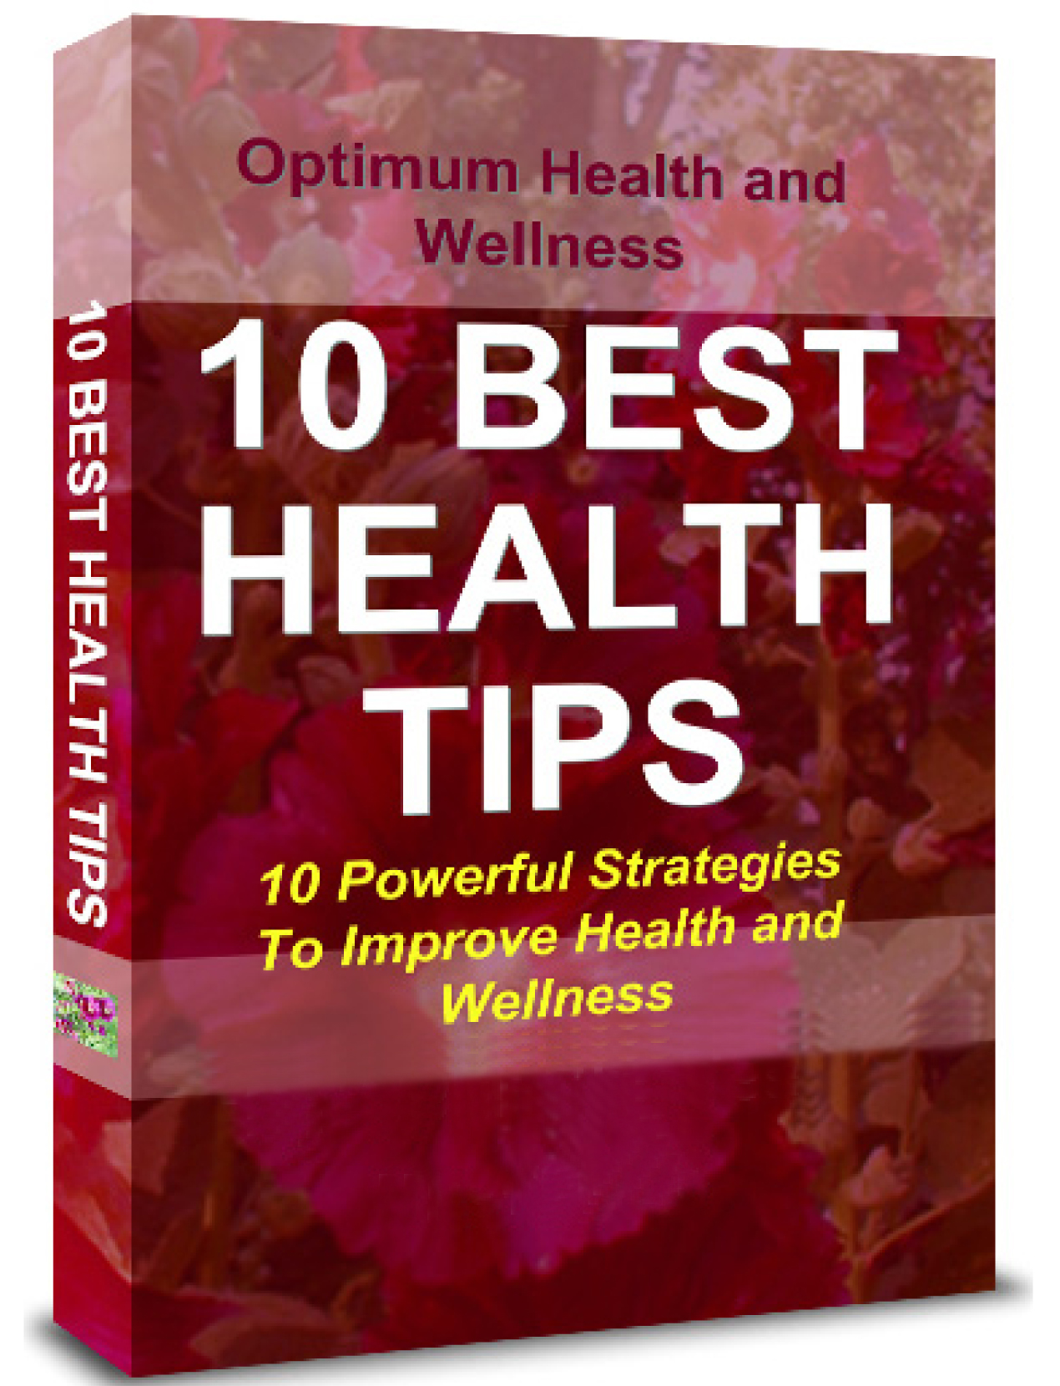
Disclaimer
The information in this book is not a replacement for the services of a physician or health care professional.
Please do not use this e-book to diagnose or treat a medical or health condition.
Please consult a physician in all matters relating to your health, and use discretion when using any of the strategies mentioned here.

Table Of Content
How To Fight Aging 7
Overcoming Anxiety.. 10
Get Enough Sleep 12
How to Avoid Cancer Caused by Smoking 14
Avoid Eye Problems Caused by
T.V.& Monitors 16
How to Beat Asthma 18
Use Heat to Cure 22
How to Combat Fatigue 24
Protect Yourself Against Cancer 26
Prevent High Blood pressure 28

Dear Patient,
You made a great decision by downloading this e-book! It includes a significant amount of information on health and wellness. You will find strategies and tips on how to deal with 10 common concerns and learn how to:
- Fight aging
- Overcome anxiety
- Care for your heart while you sleep
- Avoid cancer caused by smoking
- Minimize eye problems caused by T.V. and monitors
- Overcome asthma
- Use heat to cure
- Fight fatigue
- Protect yourself against cancer
- Prevent high blood pressure
In addition, you will now receive my exclusive newsletter. We spend a significant amount of time to put together each edition, which brings you valuable tips designed to improve your health and prevent injuries. This e-book and newsletter is my commitment to improving your health, as your healthcare provider. Thank you!
How To Fight Aging
Are you ready for a surprise?
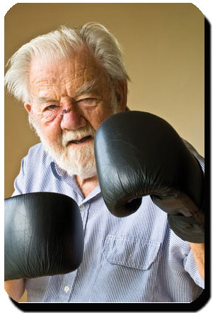
Did you know that just walking for 30 minutes, 3 to 4 times a week may be good enough to fight aging?
According to researchers at the University of California, one of the principle causes of deterioration of a individual’s physical faculties is a diminished ability to metabolize the carbohydrate glucose.

Glucose is simply a source of fuel that allows your body to function efficiently and carry out its day-to-day activities.
The study demonstrated that leisurely exercise, like taking a walk, plays an important role in keeping glucose metabolism functioning smoothly.
Do you spend the whole day sitting at your desk or in front of a computer screen? If the answer is yes, you should consider taking occasional breaks to exercise. Little breaks are simple, convenient and achievable.
Don’t overwhelm yourself and try and do too much too soon.
Take short breaks, pace yourself and if possible do some light exercises to ease your mind and energize your body.
This has become a corporate culture in some Japanese companies,. Every twenty minutes a bell sounds, and everybody takes a short break to do some stretching exercises, after which all sit down and continue their work again as if nothing happened. Japanese managers are convinced that their employees are more productive when they are relaxed.
Overcoming Anxiety..
Do you spend some or part of the day worried and anxious? Most people do, and are taking a serious toll on their health, which can develop into other psychological disorders. Psychologists at the University of Pennsylvania advice patients suffering from anxiety to do a daily twenty minute “worry session,” at the same time and in the same place, consistently. They advise patients to assimilate common concerns from the day (without fighting any negative feelings) and then pour them out in this daily worry session.

Patients can exaggerate their worries to the point of absurdity - knit their brows, make faces, let the sweat flow, shake and cower as much as they want. In other words, they are encouraged to make a caricature of the person within them that is always worried. By doing so, they face their fears head-on and deal with them..
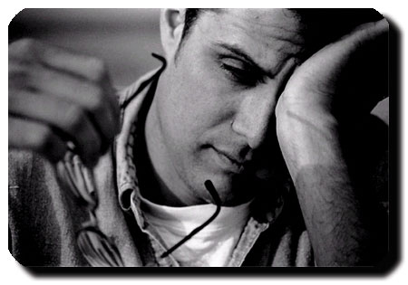
Eliminating worry is an important component of 21st century living, since we tend to live in a state of perpetual anxiety.
Get Enough Sleep
Sleeping habits can affect your life significantly. It’s important to sleep at a set time and get a minimum of 8 hours a night, although individual needs can differ.

Stress is the number one cause of short term sleep difficulties. In order to get a sufficient amount of sleep, make sure you have a regular sleep schedule. Do not consume caffeine four to six hours before bedtime. Avoid alcohol, smoking or heavy meals close to bedtime. Minimize loud sounds, light and excessive hot and cold temperatures around sleep time. Soothing fragrances and gentle, relaxing sounds with positive associations (sea breeze, ocean waves) can be helpful in some cases.
With the right sleep pattern, you should be able to wake up without an alarm clock and feel fresh and energetic, looking forward to the rest of the day.
Considering that a third of a normal person’s life is spent sleeping, it’s important to pay attention to sleep pattern and normalize or improve it.
How to Avoid Cancer
Caused by Smoking

If you smoke, you can greatly reduce the risk of contracting cancer by increasing your consumption of Vitamin E, best achieved by drinking carrot juice. According to the German Doctor Hans Nieper, founder of Eumatabolic Medicine, this is a new alternative mode of treatment which has become very popular in Germany. The carotene found especially in carrots is considered to be a deterrent to cancer.
Dr. Nieper states, “If you smoke 60 cigarettes a day but drink 4 glasses of carrot juice, you will still be less prone to contract cancer than someone who doesn’t smoke but who doesn’t drink carrot juice.” However, if you can avoid smoking and drink carrot juice you stand to benefit significantly.

Avoid Eye Problems
Caused by T.V.& Monitors
The eyes are not accustomed to focus on close objects for long periods. This puts a significant amount of stress on them. If your work requires staring at a computer screen for long hours, or if you watch a lot of television, take periodic breaks to do a few eye exercises.
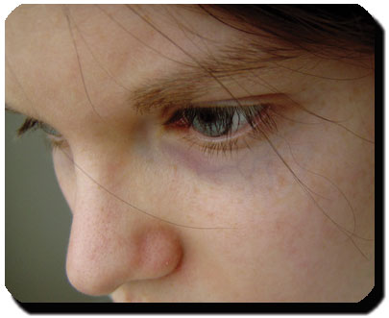
You can do any or all of the following exercises during a break:
- Roll your eyes in large circles in both directions
- Look over to each side as far as possible and then go from up to down
- Scan an imaginary text on the wall from left to right
- Look out the window as far as you can following the horizon then return to a point right in front of you and begin again.

Doing these exercises you can avoid an accumulation of strain on the muscles surrounding your eyes. In addition, these exercises will help improve your concentration and boost your work productivity.
How to Beat Asthma
Asthma partially obstructs the bronchial tubes, making it difficult to breathe. The cause of asthma is still unknown. However, if you suffer from asthma you can reduce the number of asthma attacks considerably through some natural means.
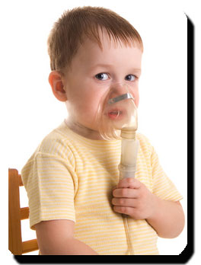
A placebo study has shown that asthmatics who consume 1 gram of vitamin C per day had 4 times fewer attacks than those who consumed no vitamin C. When they stopped taking vitamin C, the attacks resumed with the same frequency as before.
As for magnesium, it has also proven very effective in controlling the frequency of asthma attacks. Dr. Zack H. Haddad, Faculty of Medicine at the University of Southern California conducted a study on thirty children suffering from asthma associated with allergies. Twenty of them drank a daily amount of mineral water rich in magnesium, while the others received no magnesium supplement. After three months, the first group had a higher level of magnesium in their blood, and they were able to breathe more easily.
Increasing the daily intake of vitamin C and magnesium could be a good way to fight asthma. Before using vitamin C or magnesium, consult your physician for more information and to determine if these minerals are right for you.
If you are suffering from asthmatic episode, your physician may advice you to drink 2 or 3 cups of strong coffee. Coffee increases blood circulation and eases the respiratory blockage.
In addition, the American Lung Association recommends the following exercise:
- While standing, contract all your muscles. Keep them contracted for a few seconds.
- Release the muscles, like letting the air out of a balloon. Relax all your muscles completely until you feel like a limp cloth.
- Gently lie down on the floor and stretch out. Close your eyes and relax your face and your feet.
- Imagine that you are floating on water. Concentrate on the effect the earth’s gravity has on your muscles and on the pleasant feeling of being completely relaxed.

- Breathe gently and quietly, as if you were about to fall asleep.
- Open your eyes.
Practicing this exercise when you sense an impending attack may help ward off the attack or reduce its severity.
Use Heat to Cure
The soothing effects of a sauna and of the relaxing effect of a steam bath are well known.
There are other heat treatments that are equally beneficial. Heat helps relax the muscles and ligaments. When applied locally, hot towels can ease muscle spasms. Heat helps reduce arthritic pain. Heat dilates the blood vessels, which in turn activates circulation.
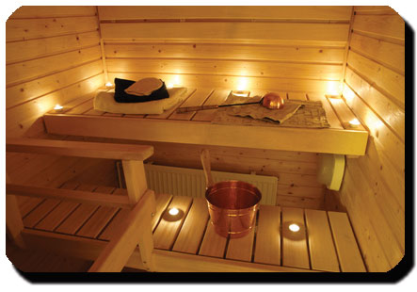
As a general principle, cold (not heat) is the remedy of choice in acute injuries (less than 48 hours old) and in injuries requiring the reduction of inflammation. When an injury is more chronic (weeks or months), heat tends to provide a better pain relieving effect.
How to Combat Fatigue
Symptoms of fatigue are associated with inadequate sleep. Therefore, you should ensure that you get enough sleep each day.
Malnutrition is another reason leading to increased stress levels or fatigue.

Avoid monotony: a varied diet with natural supplements is more likely to provide the nutritive elements you need to conserve your energy than a fixed monotonous diet.
Fatigue may be linked to emotional stress. This could occur due to tension at work or at home.
Finally, do not neglect physical exercise. Take in some fresh air every day and walk for a few minutes. Staying in shape will minimize fatigue.
Protect Yourself
Against Cancer
The free-radical theory of aging (FRTA) states that organisms age because cells accumulate free radical damage over time. A free radical is any atom or molecule that has a single unpaired electron in an outer shell.

While a few free radicals such as melanin are not chemically reactive, most biologically-relevant free radicals are highly reactive. For most biological structures, free radical damage is closely associated with oxidative damage. This is considered to be one of the causes of cancer.
Diet plays an important role in fortifying your body against their affects, especially in the absorption of anti-oxidants. The strongest anti-oxidizing agent is Vitamin E, found in wheat germ oil and sunflower seeds.
Vitamin C (oranges, grapefruits, lemons, red peppers etc.) is also beneficial.
Beta carotene also absorbs large amounts of radical liberals. This substance seems to act as a protecting agent against most types of cancer. It is found in red vegetables (like tomatoes), orange ones (carrots), yellow (squash), and dark green (broccoli). All these are rich in beta carotene.
Include these food types in your regular diet, in addition to regular exercise, and sufficient sleep.
Prevent
High Blood pressure
Research has shown that individuals with a diet rich in potassium (vegetarians for example) are less likely to develop high blood pressure.
Calcium is also beneficial. Fortunately, potassium and calcium are abundantly present in a large variety of foods.
Fruits, vegetables, beans, fish, fowl and lean meats are full of potassium.
Foods rich in calcium usually also contain large amounts of sodium and fat, which can increase blood pressure.
The following foods are recommended for individuals with high blood pressure, owing to their beneficial effects on the cardiovascular system - almonds, broccoli, beans, tofu and sardines.

