10 Best Health Tips

10 Powerful Strategies To Improve Health and Wellness

By: John Smith

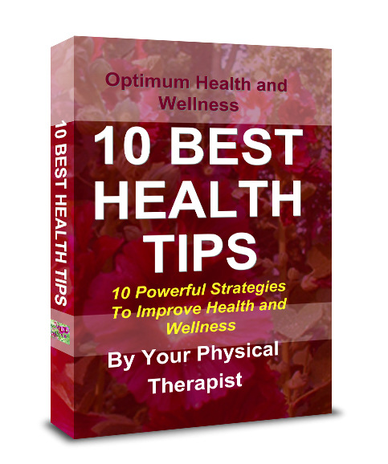

The information and advice published or made available in this book is not intended to replace the services of a physician or health care professional.
Information in this book is provided for informational purposes only and is not a substitute for professional medical advice. You should not use the information contained herein to diagnose or treat a medical or health condition.
Please consult a physician in all matters relating to your health, and use discretion when practicing any of the exercises contained herein. The author makes no representations or warranties with respect to any information offered or provided in this book regarding effectiveness, action, or application of the suggestions contained herein.

Dear Patient,
You made a great decision to request this ebook! This book is packed with information on health and wellness. You will find strategies and tips on how to deal with 10 common concerns. Learn how to:
- Fight aging
- Overcome anxiety..
- Care for your heart while you sleep
- Avoid cancer caused by smoking
- Minimize eye problems caused by T.V. and monitors
- Overcome asthma
- Use heat to cure
- Combat fatigue
- Protect yourself against cancer
- Prevent high blood pressure
More good news - you are now a part of my exclusive physical therapy newsletter mailing list, which will allow you to receive, at no cost, a brand new newsletter, twice a month in your email inbox. This newsletter is packed with valuable tips, strategies, suggestions and articles geared to help you make the most of your life. This is my way of serving you, as your physical therapist of choice.
Thank you!

How to fight aging

Did you know that just walking for 30 minutes, 3 or 4 times a week is enough to combat aging?
According to researchers at the University of California, one of the principle causes of deterioration of the human organism’s physical faculties is its diminished ability to metabolize glucose. And they showed that even leisurely exercise, like taking a walk, plays an important role in keeping glucose metabolism functioning smoothly.
Do you spend the whole day sitting at your desk or in front of a computer screen? Why not get up occasionally and do a few minutes of physical exercise? Don’t worry about what other people think.
In some Japanese companies, it is even become a collective habit. Every twenty minutes a bell sounds, and everybody gets up to do some stretching exercises, after which they sit down again as if nothing had happened. Japanese managers are convinced that their employees are more productive when they are relaxed.

Overcoming anxiety..

Is worrying one of your characteristics? Well, stop! It is okay to worry, but at the right time.
Psychologists at the University of Pennsylvania tell patients who suffer from anxiety to regularly do a daily twenty minute “worry session,” always at the same time and in the same place. Collect your head full of worries during the day (don’t suppress them!) and then pour them out during your daily worry session.
Exaggerate your worries to the point of absurdity - knit your brows, make faces, let the sweat flow, shake and cower as much as you like. In other words, make a caricature of the part of yourself that is always worried, and in so doing exorcise it.
Eliminating worry will help prevent numerous psychosomatic illnesses, which result from living in a state of permanent anxiety.

Care for your heart while you sleep

In which position do you sleep?
If you sleep on your stomach or on your left side, you are putting pressure on your heart with the extra body weight, while the heart has to continue pumping blood as usual.
This additional burden wears the heart out more quickly. Think about it – you spend more than one third of your life sleeping!
To reduce the strain on your heart, sleep on your right side, or on your back. This simple technique will add years to your life.

How to avoid cancer caused by smoking

If you smoke, you can greatly reduce the risk of contracting cancer by drinking carrot juice. This according to the German Doctor Hans Nieper, founder of Eumatabolic Medicine, a new alternative mode of treatment which has become very popular in Germany. The carotene found especially in carrots prevents and can even cure cancer.
Dr. Nieper states, “If you smoke 60 cigarettes a day but drink 4 glasses of carrot juice, you will still be less prone to contract cancer than someone who doesn’t smoke but who doesn’t drink carrot juice.” Of course, if you don’t smoke and do drink carrot juice all the better!

Avoid eye problems
caused by T.V. and
monitors

The eye was not made to be constantly focused on close objects. If your work requires that you stare at a computer screen all day long or if you watch a lot of television, stop from time to time to do a few eye exercises.
For example, roll your eyes in large circles in both directions; look over to each side as far as possible and then go from up to down; or scan an imaginary text on the wall from left to right; or look out the window as far as you can following the horizon then return to a point right in front of you and begin again.
In this way, you will avoid long term eye problems, you will enlarge your inner space, and relax both your eyes and your mind.

How to beat asthma
Asthma partially obstructs the bronchial tubes, making breathing difficult. The cause of asthma is still not known. But if you are an asthma sufferer, you can, through natural means, considerably reduce the number of asthma attacks you get.
A placebo study has shown that asthmatics who consume 1 gram of vitamin C per day had 4 times fewer attacks. When they stopped taking vitamin C, the attacks resumed with the same frequency as before (Trop. and Geog. Med., Vol. 32, Mo. 2, 1980).
As for magnesium, it also works wonders! Dr. Zack H. Haddad of the Faculty of Medicine at the University of Southern California conducted a study on thirty children suffering from asthma associated with allergies.
Twenty of them drank a daily amount of mineral water rich in magnesium, while the others received no magnesium supplement. After three months, the first group had a higher level of magnesium in their blood, and they were able to breathe more easily.
So taking vitamin C and magnesium is an excellent way to prevent asthma attacks.
But what can you do to breathe more easily during an attack? Simply drink 2 or 3 cups of strong coffee. By activating blood circulation, it eases respiratory blockage.
In addition, the American Lung Association recommends the following exercise:
- While standing, contract all your muscles. Keep them contracted for a few seconds.
- Release the muscles, like letting the air out of a balloon. Relax all your muscles completely until you feel like a limp cloth.
- Let yourself fall to the floor, and stretch out. Close your eyes and relax your face and your feet.
- Imagine that you are floating on water. Concentrate on the effect the earth’s gravity has on your muscles and on the pleasant feeling of being completely relaxed.
- Breathe gently and quietly, as if you were about to fall asleep.
- Open your eyes.
Practicing this exercise when you feel an attack coming on, or once it is already started, will help you overcome your asthma condition.

Use heat to cure

Everyone has heard about how good a sauna feels, and of the relaxing effect of a steam bath which bathes you in hot vapor.
But there are other heat treatments which are equally beneficial. Heat relaxes the muscles and ligaments. When applied locally, for example, with hot towels, it can ease muscle spasms. It can also reduce arthritic pain. Heat dilates the blood vessels, which in turn activates circulation.
Applied to a wound, it can prevent infection by helping white blood corpuscles and fresh oxygen surround the area more quickly.

How to combat fatigue

First make sure you are sleeping enough.
Is your nutrition sufficient? In general women need at least 1200 calories per day and men 1500.
Avoid monotony: a varied diet will be more likely to provide the nutritive elements you need to conserve your energy.
The sensation of fatigue may be stress-related, especially when you experience emotional stress. Do you feel tense at work or at home?
Lastly, don’t neglect physical exercise. Tired or not, get out in the fresh air every day. Walking is the minimum effort necessary for staying in shape.

Protect yourself against cancer

Radical liberals are not a political group, but a kind of very active molecule that is suspected of being one of the causes of cancer.
How can you protect yourself? Diet plays an important role here, especially in the absorption of anti-oxidants. The strongest anti-oxidizing agent is Vitamin E, which is found in wheat germ oil and sunflower seeds.
Next comes Vitamin C (oranges, grapefruits, lemons, red peppers etc.).
Beta carotene also absorbs large amounts of radical liberals. This substance seems to act as a protecting agent against most types of cancer.
Where do you find it? In red vegetables (like tomatoes), orange ones (carrots), yellow (squash), and dark green (broccoli). All these are rich in beta carotene. So make them a regular part of your menu!

Prevent high blood pressure

Research has shown that people whose diet is rich in potassium (vegetarians for example) are less likely than others to develop high blood pressure.
Calcium is also beneficial. Fortunately, potassium and calcium are abundantly present in a large variety of foods.
Fruits, vegetables, beans, fish, fowl and lean meats are full of potassium.
Calcium is a little more restricted. Foods rich in calcium usually also contain large amounts of sodium and fat, which can increase blood pressure.
However, moderate amounts of milk are recommended, as well as yogurt, almonds, bananas, grapes, broccoli, potatoes, beans, tofu and sardines.

